[R](http://theautomatic.net/category/r/" \t "_blank) offers several ways to reverse a string, include some base R options. We go through a few of those in this post. We’ll also compare the computational time for each method.

Reversing a string can be especially useful in bioinformatics (e.g. finding the [reverse compliment](https://www.bx.psu.edu/old/courses/bx-fall08/definitions.html) of a DNA strand). To get started, let’s generate a random string of 10 million DNA bases (we can do this with the **stringi** package as well, but for our purposes here, let’s just use base R functions).

set.seed(1)

dna <- paste(sample(c("A", "T", "C", "G"), 10000000, replace = T), collapse = "")

**1) Base R with strsplit and paste**

One way to reverse a string is to use **strsplit** with **paste**. This is the slowest method that will be shown, but it does get the job done without needing any packages. In this example, we use **strsplit** to break the string into a vector of its individual characters. We then reverse this vector using **rev**. Finally, we concatenate the vector of characters into a string using **paste**.

start <- proc.time()

splits <- strsplit(dna, "")[[1]]

reversed <- rev(splits)

final\_result <- paste(reversed, collapse = "")

end <- proc.time()

print(end - start)

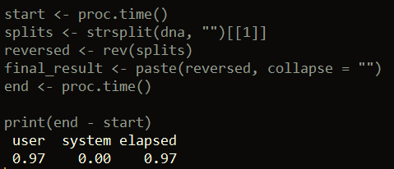

**2) Base R: Using utf8 magic**

This example also does not require any external packages. In this method, we can use the built-in R function **utf8ToInt** to convert our DNA string to a vector of integers. We then reverse this vector with the **rev** function. Lastly, we convert this reversed vector of integers back to its original encoding – except now the string is in reverse.

start <- proc.time()

final\_result <- intToUtf8(rev(utf8ToInt(dna)))

end <- proc.time()

print(end - start)

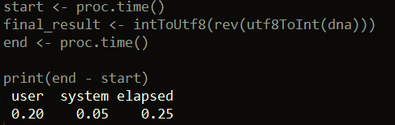

**3) The stringi package**

Of all the examples presented, this option is the fastest when tested. Here we use the **stri\_reverse** function from the [stringi package](https://www.rdocumentation.org/packages/stringi/versions/1.4.3?tap_a=5644-dce66f&tap_s=10907-287229).

library(stringi)

start <- proc.time()

final\_result <- stri\_reverse(dna)

end <- proc.time()

print(end - start)

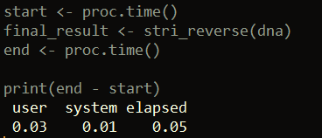

**4) The Biostrings package**

Our last example uses the [Biostrings package](https://web.stanford.edu/class/bios221/labs/biostrings/lab_1_biostrings.html), which contains a collection of functions useful for working with DNA-string data. One function, called **str\_rev**, can reverse strings. You can download and load the Biostrings package like this:

source("http://bioconductor.org/biocLite.R")

biocLite("Biostrings")

library(Biostrings)

Then, all we have to do is input our DNA string into the **str\_rev** function and we get our result.

start <- proc.time()

final\_result <- str\_rev(dna)

end <- proc.time()

print(end - start)

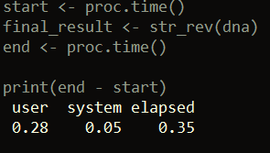

That’s it for this post! [Please check out my other articles here](http://theautomatic.net/blog/).

The post [Four ways to reverse a string in R](http://theautomatic.net/2019/05/17/four-ways-to-reverse-a-string-in-r/) appeared first on [Open Source Automation](http://theautomatic.net/).